**User Guide**

**Before starting the app**

1. **Setting up the DB**

Open pgAdmin app, and restore database from the “webshopdb.sql” file.

2. **Allowing the mail to use other services**

To properly use the mail service of the app, you need to login to Gmail with the credentials provided in the .env file and make sure that ‘Less secure app access’ is on:  
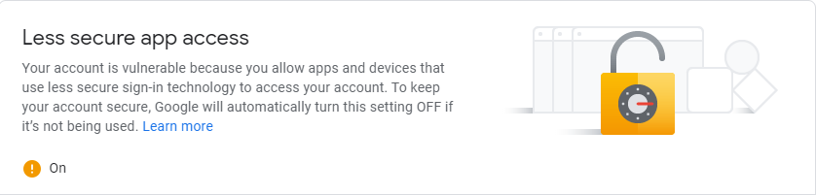

Located under: Account -> Manage your Google Account -> Security.

3. **Setting up the project**

Extract the RAR file with the project to the working directory.

Edit .env file to your credentials (username, password, etc.).

Add .env file to the project folder.

Open the terminal in the project folder.

Run “npm install” in the terminal.

Run “node app.js” in the terminal.

Open your browser and run “localhost:3000” in the address bar.

**After Starting the App**

1. **Login Screen**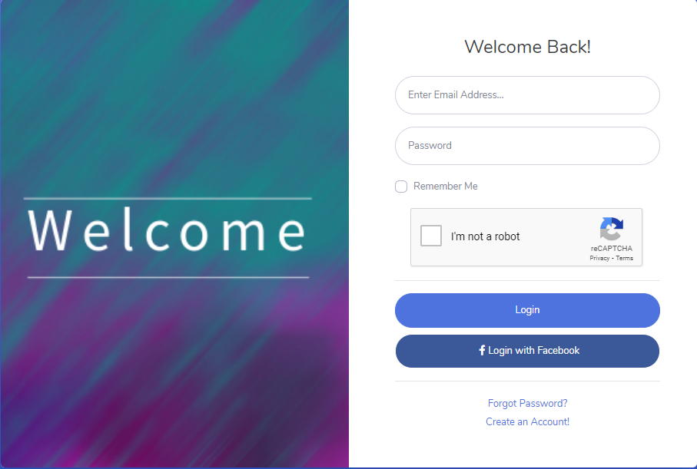

This is the starting page. Here you can login into your account, whether you registered through our site or you can login with Facebook.

If you don’t have an account, and you don’t wish to use Facebook, you can create account by clicking on Create an Account!

If you do have an account but you forgot the password, you can reset your password by going to the Forgot Password? page.

2. **Registration**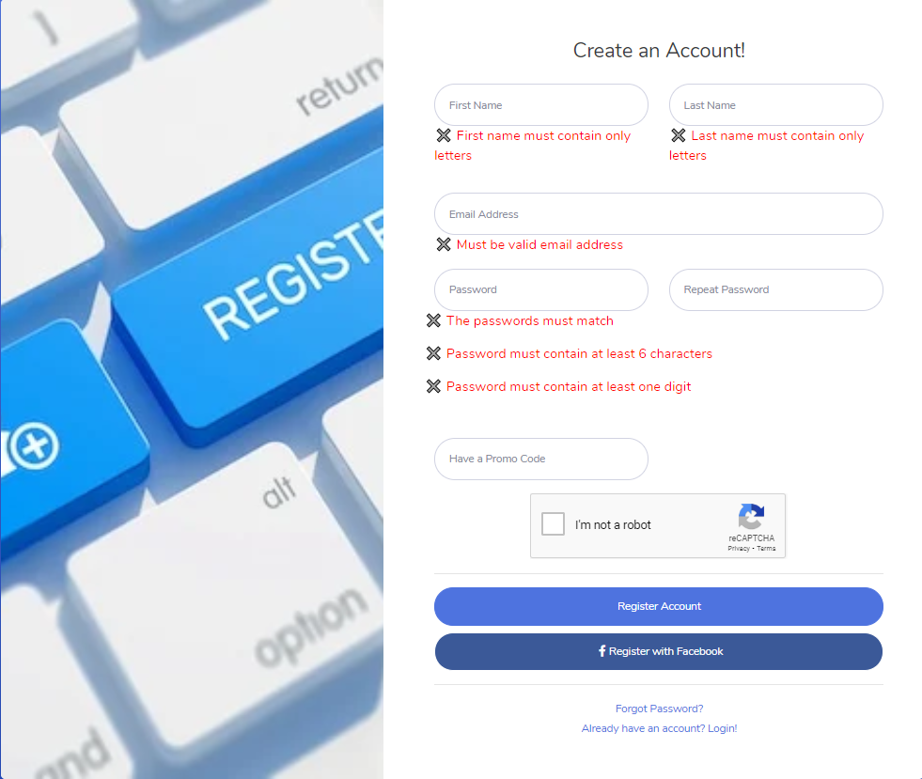

On this screen you can register your account. Read carefully the fields validations – each successful validation will turn into green and you won’t be able to proceed until you selected the captcha and all validation fields are green. You don’t have to fill the promo code filed to complete the registration process. If you wish to create your account with Facebook, you can do it by pressing Register with Facebook.

If you have an account and you forgot your password you can reset your password by clicking on Forgot Password?

You can go back to login page by clicking on Already have an account? Login!

3. **Forgot Password  
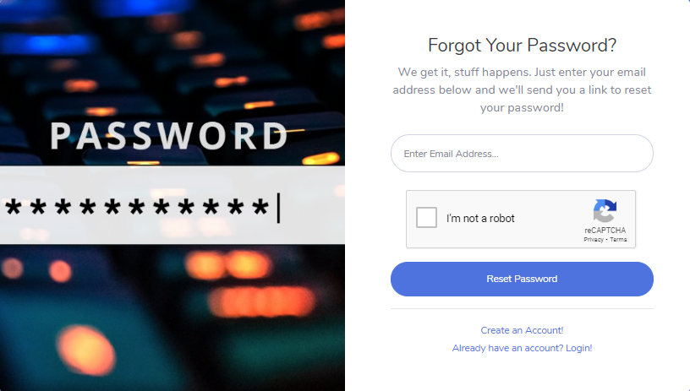**

If you have a user, you enter your mail and you’ll receive a message into this mail with link to reset password.

4. **Main Screen  
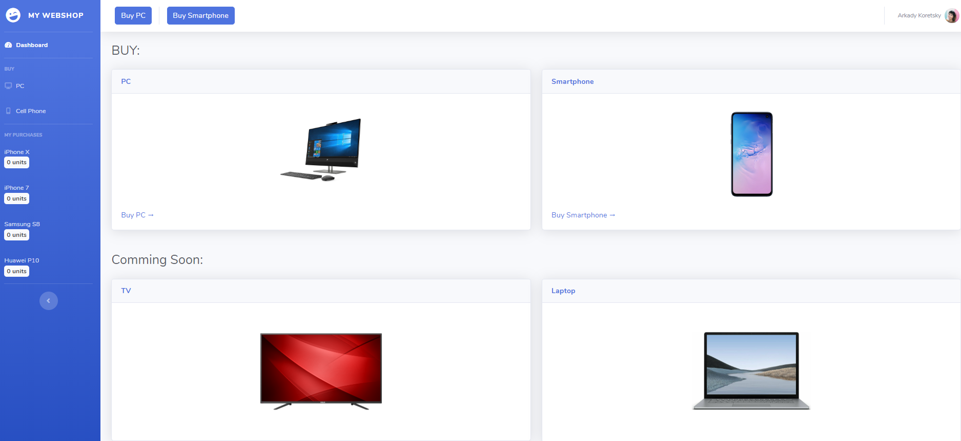**

You proceed to this screen after registration or successful login.

At this screen you can choose to purchase a PC or smartphone.

If you’ll click Buy PC, you’ll be redirected to ‘under construction’ page. If you’ll click Buy Smartphone, you’ll be redirected to purchasing page.

By clicking on your name at the top right corner, you can go to your profile page, or go to about page, or logout.

5. **Buy Smartphone**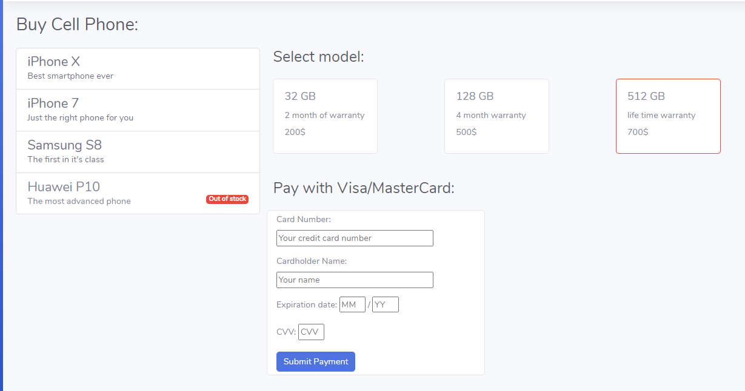

For purchase:

You select the Cell phone, after that you select the model, and then you fill in your credit card details for submission.

After purchasing, the unit will be added to the left bar at the main screen and mail with details will be sent to your login mail.

6. **Profile**

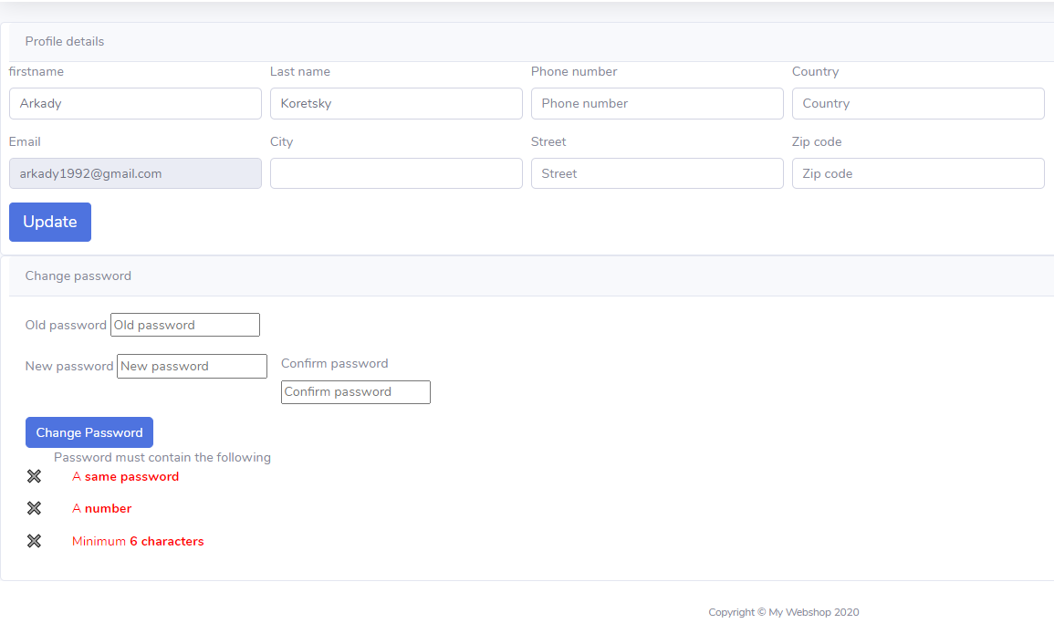

At this page you can update your details or change your password. You’ll receive a confirmation mail that your details updated successfully.